St. Stephen’s College Alumni Association

SSCAA 2015 Homecoming

Boarding Experience @ College House

August 8-9, 2015

SSCAA Homecoming is an event to let our participants rekindle with our lovely School Campus with their kids, family and fellow alumni. We sincerely invite you to join us for a boarding experience at the new dormitory - College House!

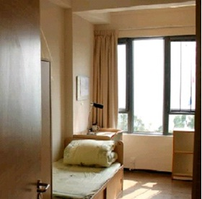
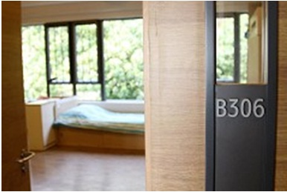
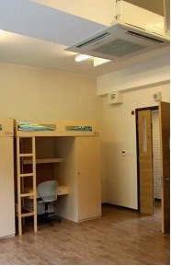
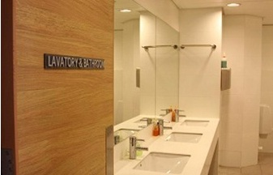
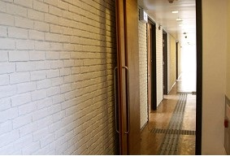
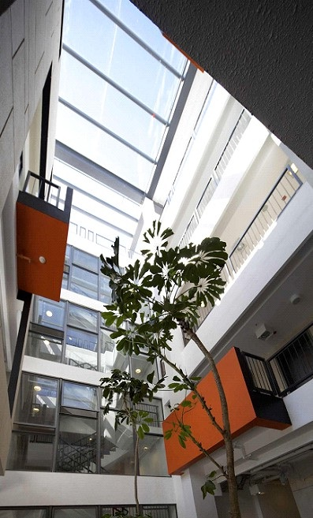
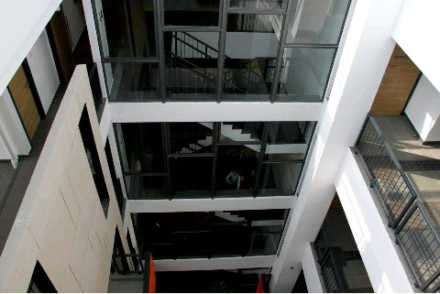
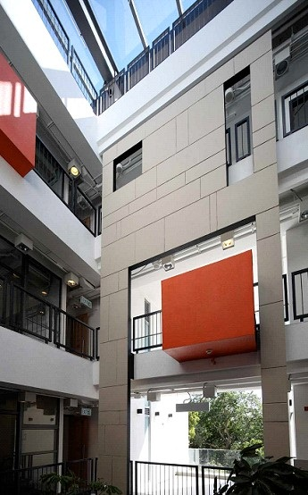
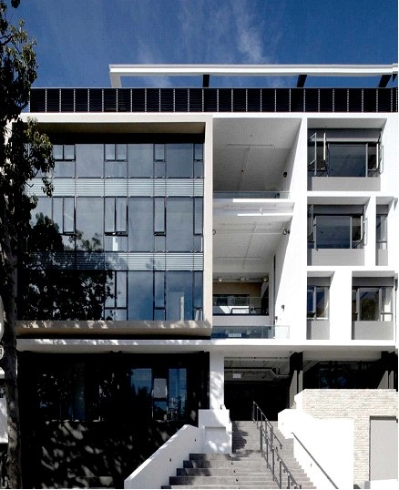

SSCAA 2015 Homecoming

August 8-9, 2015
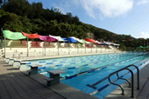
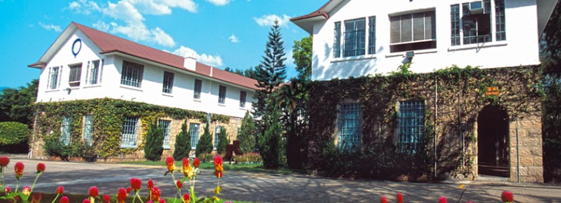
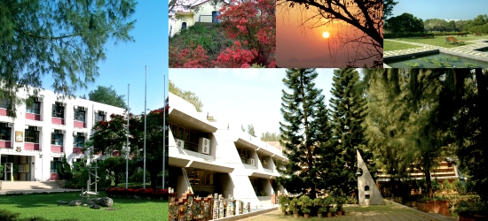

Program
Day 1: August 8, 2015 (Sat) |  |  | Day 2: August 9, 2015 (Sun)
3:00-3:30pm | Registration & Check-in |  | 8:00-9:00am | Breakfast
3:00-6:30pm | Sport Facilities Open: Martin Hostel Basketball Court, and Swimming Pool |  | 9:30am | Chapel Service Available
3:30-4:30pm | Class: Let’s make Pudding  *Extra charge for ingredient costs applies. 10 teams or 2-3 people maximum. |  | 9:30-11:30am | Experience Dragon-boat*  Hosted by SSCAA Dragon Boat Team  *Extra charge applies. All participants are required to wear safety jackets provided. Minimum Age: Age 10 with adult supervision
6:30pm | Dinner Reception  SSCAA Souvenirs Sale
7:00pm | Dinner at Main Dining Hall |  | 12:00-1:00pm | Lunch
 |  |  | 1-1:30pm | Check-out
11:00pm | Lights Out

Fees
Description | Fees
Day Camp:  Aug 8 Only | $150 per guest; Children under the age of 3: Free of Charge  Price included school-style dinner at College Dining Hall
Overnight Camp: | $150 per person PLUS Room & Food Costs  Room & Food: $850 per 2-person room; $1600 per 6-person room
Pudding Class: | $150 per team of 3 people ; 10 teams limit
Experience Dragon Boat: | $50 per person (All must wear safety jackets provided by SSCAA)  10 people minimum, 18 people maximum
Parking: | FOC for paid guests; Registration required with License Plate No.
Rooms and Activities Spaces are limited! Priority will be given to those who pay first!

How to Apply
Please complete the Enrollment Form with payment details and email to homecoming@sscaa.org before July 24, 2015. Our Homecoming committee shall email confirmation within 10 days of receipt. If we are unable to accommodate your room choice, we shall issue a full refund.

For Enquiry, please contact homecoming@sscaa.org

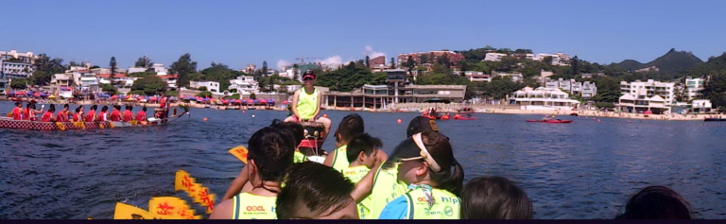

SSCAA 2015 Homecoming (August 8-9, 2015)

Enrollment Form
Please send completed form to homecoming@sscaa.org before July 24, 2015.

Name: |  |  | Year | Graduated Form 5
Contact Phone |  |  | Email
Mailing Address:
Membership No. |  |  |  | Vehicle Plate No.
Enrollment Details
Homecoming |  | Limit |  | Enrollment | Fees |  | Total
Joining Fee (Covers Day-camp) |  | Not Applicable |  | Guest(s) | $150 per person
Room Only: 2-person Room |  | 8 Rooms |  | Room(s) | $850 per Room
Room Only: 6-person Room |  | 12 Rooms |  | Room(s) | $1,600 per Room
Activities |  | Limit |  | Enrollment | Fees |  | Total
Class: Let’s Make Pudding! (Aug 8) |  | 10 Teams of 2-3 |  | Team(s) | $150 per Team
Experience Dragon Boat (Aug 9)  Must be Age 10 or over with Adult Supervision |  | 10-18 people |  | Guest(s) | $50 per Person
 |  |  |  |  | Total
Payment Information:
☐I have enclosed a deposit slip for a deposit made to HSBC Account on ___________ in the Amount of $_____________

SSCAA Account Information:
Bank Name: Hongkong and Shanghai Banking Corporation
Account Name: St. Stephen’s College Alumni Association Limited
Account Number: 848-376661-838

Remarks
Cancellation Policy
If we experience Red or Black Rain Storm Warning or No. 3 Typhoon or above by 8am on August 8, the Event will automatically be cancelled. SSCAA reserves the right to cancel and the Event in consideration of unexpected situation. Please check www.sscaa.org for latest news. Upon cancellation, SSCAA shall issue a $100 refund shall be issued to each paid day-campers and a 80% refund shall be issued to all paid rooms.

Rights of the Event Organizer & Important Notice to the Attendees
Event Principles:
(1) Safety for all individuals;
(2) Respect of the College property; AND
(3) Compliance with the Event’s House rules & College regulations.
SSCAA reserves the right to evict any individual or any group of attendees from the Event and the College campus when one or more of the above principles are deemed breached. The ruling will be jointly made by the (a) SSCAA’s Homecoming Housemaster, and (b) SSCAA’s President; and are considered final. No refund of any fees will be given to any evicted person(s).

Liability Release Form
Each guest is also required to sign a Liability Release Form relieving SSCAA and the College for liability upon Registration.

2015 Homecoming Information

August 8-9, 2015
Day Camp: | Overnight Camp:
- Parking: On campus; please park at designated parking spaces. Pre-registration required: please send your license plate # to homecoming@sscaa.org
- Check-in: 3:00pm at College House lobby
- For after-hour check-in, please call Dickson Leung at 62092206
- Drinks: Distilled water is provided.  - Only Dinner (Aug 8) will be provided; round table of 6 | - Drinks: Distilled water is provided.  - Dinner(Aug 8), Breakfast (Aug 9) and Lunch (Aug 9) will be provided; round table of 6
Sport Facilities Reserved  - Outdoor: Martin Hostel Basketball and Volleyball Court  Please respect College property and the safety of your own and others. | About Your Room:  - Room number will be assigned during Check-in. Guests are responsible for safe-keeping their keys.  - Each room has air-conditioning and pillow, blanket, bed sheet and mattress and toilet paper are provided.  - Security at College entrances: valid membership card OR pre-registration is needed to enter the campus  - Gate Closure: follow College regulation  Please respect College property and the safety of your own and others.
- What to bring: Your own sports equipment, accessories and appropriate clothing; insect repellent, sun block, jacket and/or umbrella  - What NOT to bring: Valuable belonging or harmful items | - What to bring for Day: Your own sports equipment, accessories and appropriate clothing; insect repellent, sun block, jacket and/or umbrella  - What to bring for Overnight: Washroom amenities, towels and change of clothes  - What NOT to bring: Valuable belonging or harmful items
 | - Emergency Contact: Housemaster information available at Check-in

Liability Release Form to be signed at Registration

I, the undersigned, am a participant of 2015 Homecoming (the “Event”) hosted by St Stephen's College Alumni Association Limited (“SSCAA”) and taken place at St. Stephen’s College (the “College”). I represent that I am physically fit to attend the Event and its activities and understand the risks associated with the same.
On the Date Signed, intending to be legally bound hereby, I agree and hereby release from liability and to indemnify and hold harmless the College and SSCAA, and any of their servants, employees or agents representing or related to the College or SSCAA with regards to the Event.
This release is for any and all liability for personal injuries (including death) and property losses or damage occasioned by, or in connection with any activity or accommodations for the Event. I further agree to abide by all the rules and regulations promulgated by SSCAA and/or its affiliate groups and vendors throughout the Event.
_____________________  Full Name:  Date Signed: | _____________________  Full Name:  Date Signed: | _____________________  Full Name:  Date Signed: | _____________________  Full Name:  Date Signed:

